***CHAPTER 8: Organizing Structure and Design***

**Organizing as a Management Function:**

* **Organizing:** process of arranging people and other resources to work together to accomplish a goal.
* **Organization structure:** system of tasks, workflows, reporting relationships, and communication channels that link together diverse individuals and groups.
* **A structure should:** allocate tasks through a division of labor, provide for the coordination of performance results

**Formal structures:** structure of the organization in its official state.

* Organization chart: diagram that shows reporting relationships and the formal arrangement of work positions within an organization
* Organization chart is made for learning the basics of an organization’s formal structure:

1. Division of work (position and titles show work responsibilities)
2. Supervisory relationships (who reports to whom)
3. Communication channels (lines show formal communication flows)
4. Major subunits (managers through managers)
5. Levels of management (vertical layers)

**Informal Structures:**

* Shadow organization made up of the unofficial, but other critical, working relationships between organization members
* Avoiding the traditional structure of an organization
* Can be necessary for better working relationships
* **Advantages:** help fill the void

1. Helping people accomplish work
2. Overcoming the limited formal structure
3. Access to interpersonal networks
4. Informal learning

* **Disadvantages:**

1. May work against best interests
2. Susceptibility to rumors
3. May carry inaccurate information
4. May breed resistance to change
5. Feeling alienation by outsiders (ex: American managers feeling out of the circle in a Japanese firm)
6. Diversion of work efforts from important objectives

**Traditional Organization Structures:**

**Departmentalization:** grouping work positions into formal departments that are linked together

1. **Functional structures:**

* People with similar skills and performing similar tasks are grouped together into formal work units
* Members of functional departments share technical expertise, interests, and responsibilities
* Not limited to businesses (ex: banks and hospitals), work well for small organizations

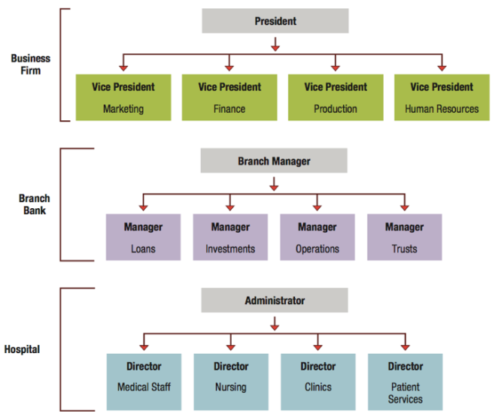

**Advantages:**

* Economies of scale, efficient use of resources
* Task assignments consistent with expertise and training
* High-quality technical problem solving
* In-depth training, skill development, clear career paths within functions

**Disadvantages:**

* Pinpointing responsibilities (containment, product or service quality, innovation)
* Functional chimney problem (lack of communication, coordination, problem solving across functions)
* People’s cooperation can break down as everyone goes about the daily work
* Narrow view of performance objectives
* Problems are too often referred up to higher levels for resolution (slows decision-making and can harm organizational performance)

1. **Divisional structures:**

* Groups together people who work on the same product or process
* Serve similar customers and/or are located in the same area or geographical region
* Common in complex organizations with diverse operations that extend across many products, territories, customers and work processes
* Avoid problems associated with functional structures

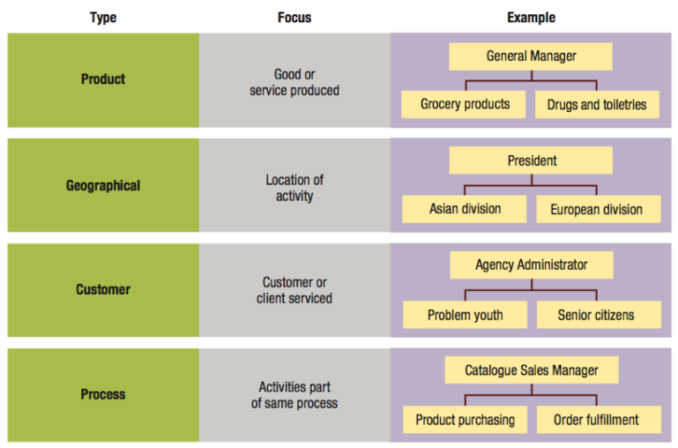

**Advantages:**

* More flexibility in responding to environmental charges
* Improved coordination
* Clear points of responsibility for product or service delivery
* Expertise focused on specific customers, products, regions
* Greater ease in restructuring

**Disadvantages:**

* Reduce economies of scale and increase costs through the duplication of resources and efforts across divisions
* Create unhealthy rivalries as divisions compete for resources and top management attention.
* Emphasis on divisional goals at expense of organizational goals

1. **Matrix Structures:** Combines both functional and divisional structures (2 bosses):

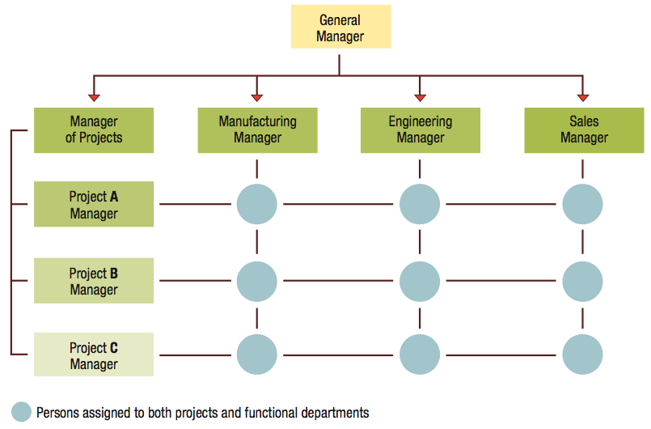

* **Advantages:**
  + Better cooperation across functions.
  + Improved decision making.
  + Increased flexibility in restructuring.
  + Better customer service.
  + Better performance accountability.
  + Improved strategic management.
* **Disadvantages:**
  + Two-boss system is susceptible to power struggles.
  + Two-boss system can create task confusion and conflict in work priorities.
  + Team meetings are time consuming.
  + Team may develop “groupitis.”
  + Increased costs due to adding team leers to structure.